# Android Email Configuration

This guide explains how to configure your Android device to access your email account.This tutorial was created running the Android 6 OS. If you are using different hardware or a different OS version, these instructions may differ.

**How do I find my email cluster?**

In order to setup your email client, you will need to know which email cluster your account is hosted on. If you don't know this information, you can check with your email service provider, or try logging into webmail at:

**Cluster A:**

http://mail.hostedemail.com

**Cluster B:**

http://mail.b.hostedemail.com

If you are able to successfully login to the webmail interface, then you have found your mail cluster. If you are not able to login to either cluster, please contact your email service provider for support.

## Step 1: Open the Email application

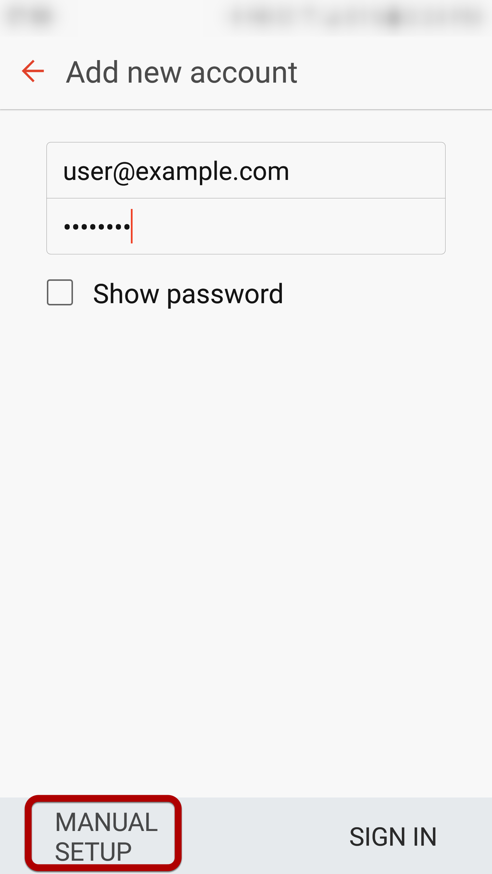

Enter your email address and select **Manual Setup**

## 

## Step 2: Select account type

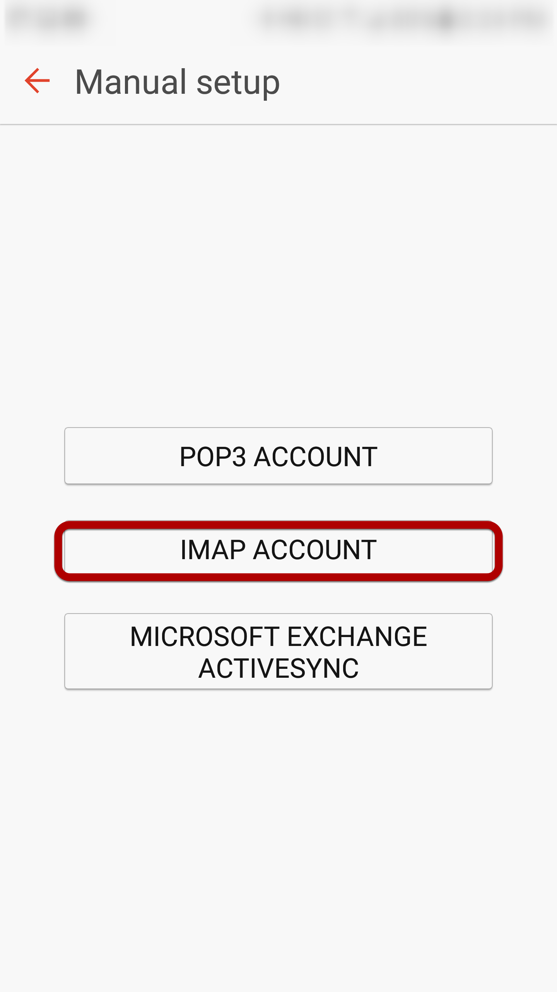

Select **IMAP Account**

## 

## Step 3: Enter Incoming Account Settings

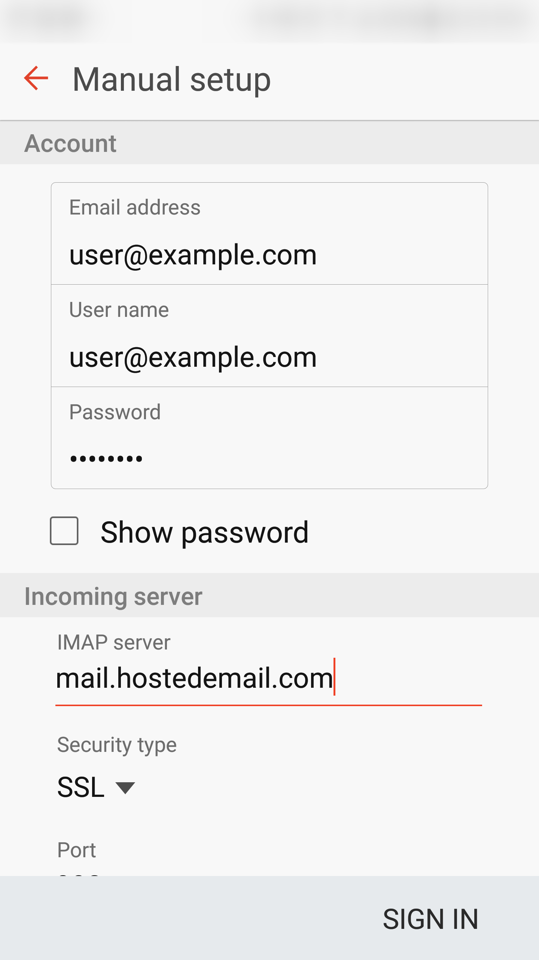

**Enter the following information:**

**Username** Enter your full email address.

**Password**

The **Password** field is automatically filled in with the password that you created when you set up your email account.

**IMAP server**

This is the name of the server which holds your email. Enter **mail.hostedemail.com (Cluster A) or mail.b.hostedemail.com (Cluster B)**

**Port:**

993

## Step 4: Enter Outgoing Server Settings

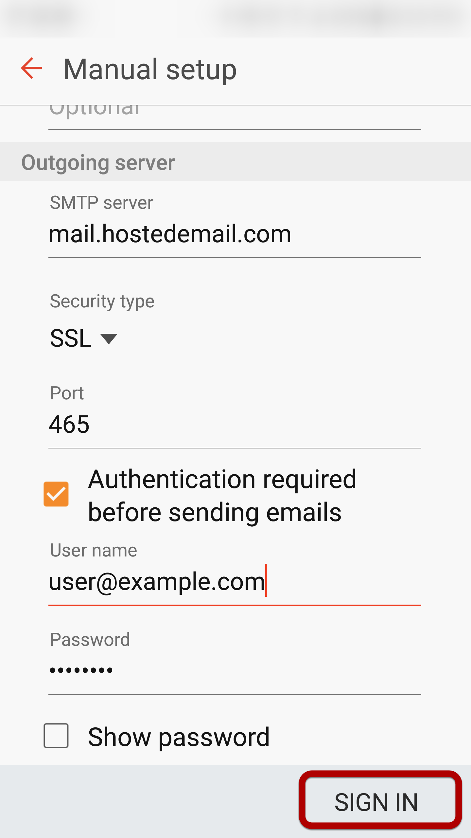

**Enter the following information:**

**SMTP Server:**

mail.hostedemail.com (Cluster A) or mail.b.hostedemail.com (Cluster B)

**Port:** 465

**Security Type:** SSL / TLS

**Username:** Your email address

**Password:**

Your email account password

Click **Sign In** to complete the setup process.